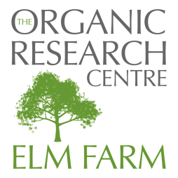


Wakelyns Open Day
Thursday 28th June 2012

Wakelyns Agroforestry, Metfield Lane, Fressingfield, Eye, Suffolk IP21 5SD

REGISTRATION FORM
DEADLINE FOR REGISTRATION Monday 18th June 2012

PARTICIPANT DETAILS (please complete a separate form for EACH participant attending):

Title: | First Name: |  | Last Name:
Organisation:

Address:
 |  | Postcode:
Email:
Telephone:

Special dietary requirements Vegetarian  Vegan  Other 

Any other special requirements (i.e. wheelchair access, etc)  (please give details):

Cost per person £25 + VAT (£30 total)
Includes lunch and all refreshments

Payment by CREDIT CARD:
Please submit form by EMAIL or FAX (details below) and then call 01488 658279 to pay over the telephone.

Payment by BANK TRANSFER:
Please submit form by EMAIL or FAX (details below)
Bank: Triodos
A/c No: 20227140

Sort Code: 16-58-10

Please include Reference “WAF 06/2012” with your initials

PAYMENT BY CHEQUE:

Please post this form together with your cheque made out to The Organic Research Centre to:

The Organic Research Centre,

Elm Farm,

Hamstead Marshall,

Newbury, Berkshire, RG20 0HR.

E-mail: gillian.w@organicresearchcentre.com

Fax: 01488 658503

Telephone: 01488 658279

